PRACTICAL 4: PATCH PANEL INSTALLATION
Objective
Install and document a patch panel.
Activities
- Mount patch panel.
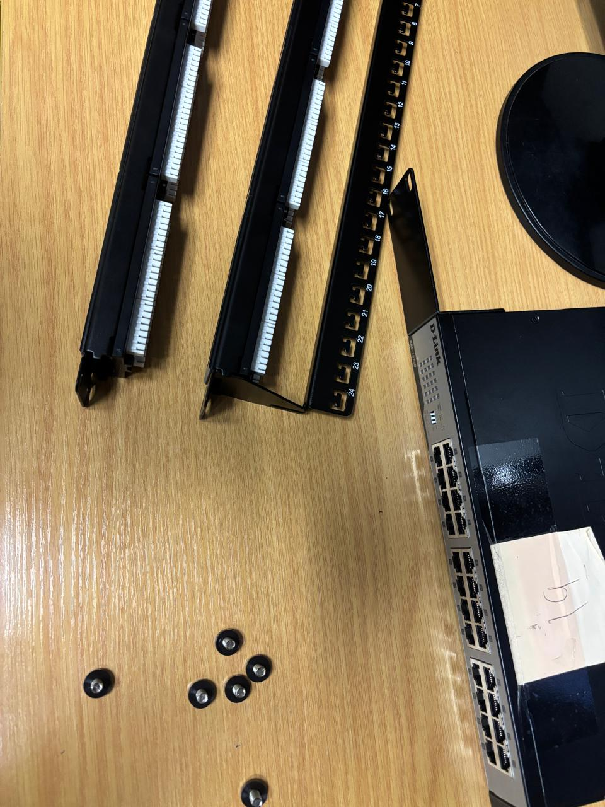
Figure 1: Patch Panels and Screws
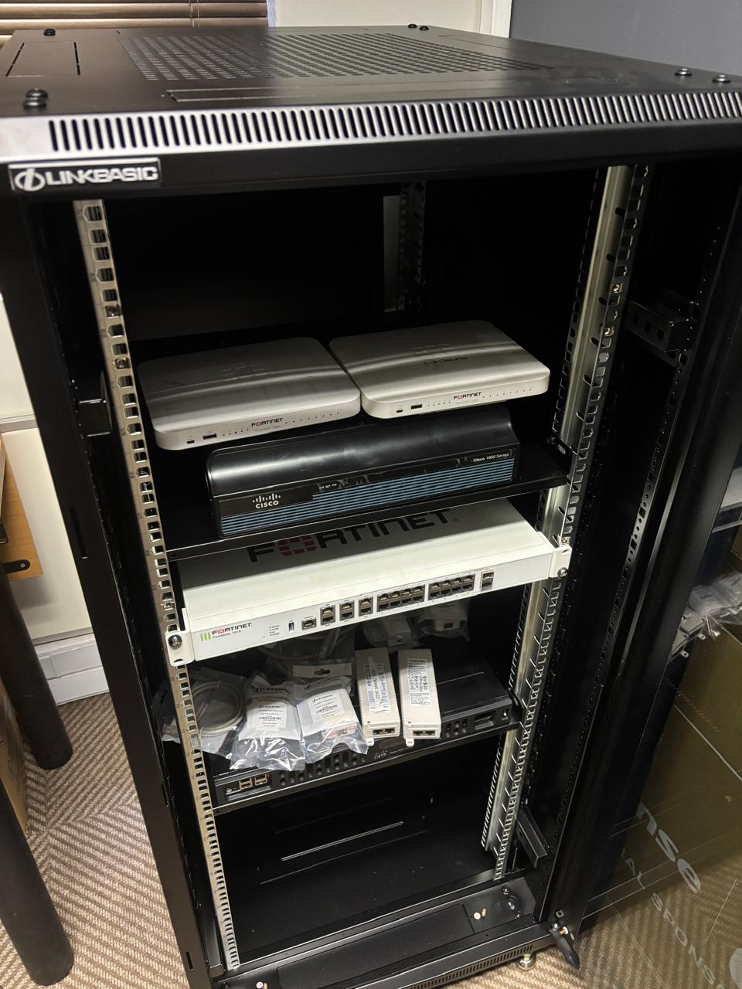
Figure 2: Before Patch Panel Installation
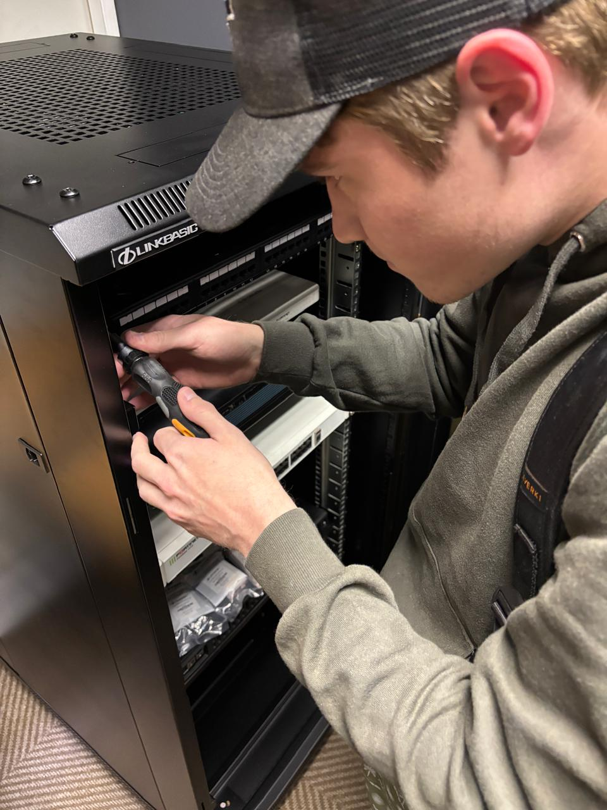
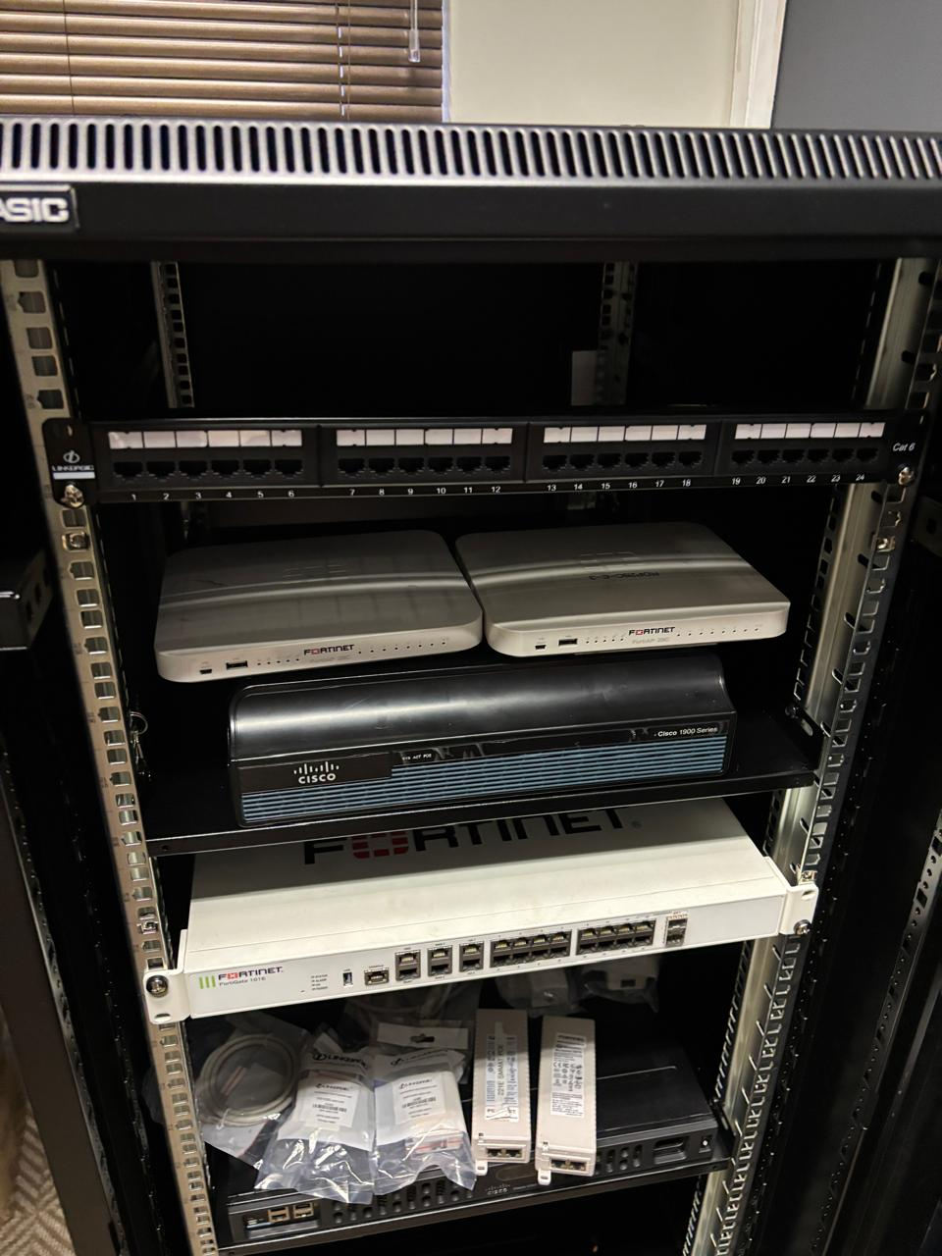
Figure 3: Mounted Patch Panel
A patch panel is a mounted piece of hardware with many network ports. It acts as a central connection hub for organizing, labeling, and managing incoming and outgoing network cables in a building.

- Terminate network runs.
- Label ports.
- Create port schedule.
- Test all ports.

Assessment Rubric (10 Marks) Criteria | Marks
Correct patch panel termination | 4
Port numbering | 2
Documentation | 2
Testing verification | 2
Total | 10

